Classification codes
Cooling down

Task code 4EC018

Description This practical task requires students to investigate how quickly hot water cools down in different coloured containers. Students are then asked to consider other factors which may affect the cooling process.

Conceptual strand / context Natural and processed materials Life and living
Energy and change Earth and beyond

Task type Objective Open ended Practical

Learning outcome focus Concept Process

Task focus level 1 2 3 4 5 6

Assessment purpose Diagnostic Formative Summative

Keywords temperature, time, conduction, radiation

Items | 1 | 2 | 3 | 4 | 5 | 6
Highest scientific
literacy level
Conceptual strand / context
Domain
Response type
Assessment purpose

Items | 7 | 8 | 9 | 10
Highest scientific
Literacy Level
Conceptual strand / context
Domain
Response type
Assessment purpose

Equipment required

Per group:
- Three polystyrene cups (one painted black, one normal white, one with aluminium foil wrapped around it) with a ‘fill to’ level marked inside each
one. Variations on this are possible: aluminium drink cans for example,
and a measured amount of water rather than a ‘fill to’ level.
- Three thermometers.
- Measuring jug.
- Water supply–hot water (teacher to supply in a jug – maximum
temperature 50⁰C).
- Three retort stands, three bossheads, and three clamps if available.

Teacher-led instructions for practical task
- Warn students about the dangers of working with hot water.
- Remind students to let the thermometer settle before they note the reading. (Remind students that they must not use the thermometer as a stirring rod.)
- This experiment is approximate only – it is not expected to be extremely accurate, as long as students get the idea.
- The teacher could demonstrate the procedure for the whole class.

Task / Teacher record sheet

Student: _______________________

Collect the equipment from your teacher.

Look at the three thermometers. Write down the temperature shown by each thermometer.

Thermometer 1 _____ ⁰C, Thermometer 2 _____ ⁰C, Thermometer 3 _____ ⁰C
4EC018Q1
- What is the approximate room temperature?
______ ⁰C

Set up three polystyrene cups – one normal, one painted black and one with aluminium foil wrapped around it.

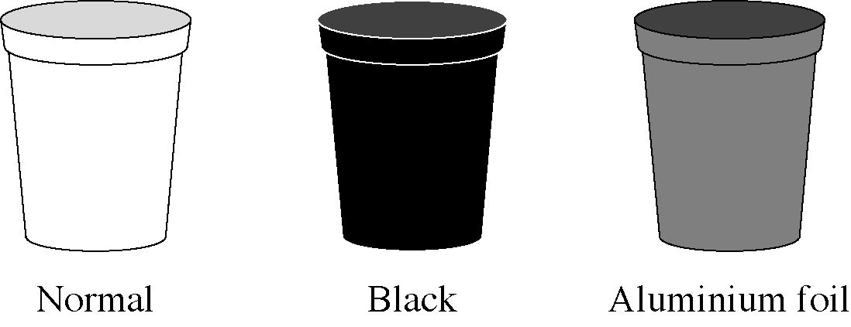

You or your teacher must put hot water into each of the three cups up to the fill mark.

Put a thermometer into each cup. Make sure it is stable – hold it at the tip, or use a boss head clamp and retort stand.

Measure the temperature of the water in each cup. Allow the thermometer a few seconds to settle at a temperature. (Do not use the thermometer as a stirring rod.)

4EC018Q2
- Complete the row in the table for the starting time (0 minutes).
Every three minutes, repeat the measurements and record your results.

 | Temperature ⁰C
Time (minutes) | Normal | Black | Aluminium
0
3
6
9
12
15

4EC018Q3
- Which colour cup cooled down the most?

4EC018Q4
- Why do you think the cup in Q3 cooled down the most?

4EC018Q5
- Was the first temperature measurement for the water in each cup the same?
If not, why not?

4EC018Q6
- Why did you use the same amount of hot water in each cup?

4EC018Q7
- Plot a line graph of temperature against time. Put all three sets of results on the same axes.

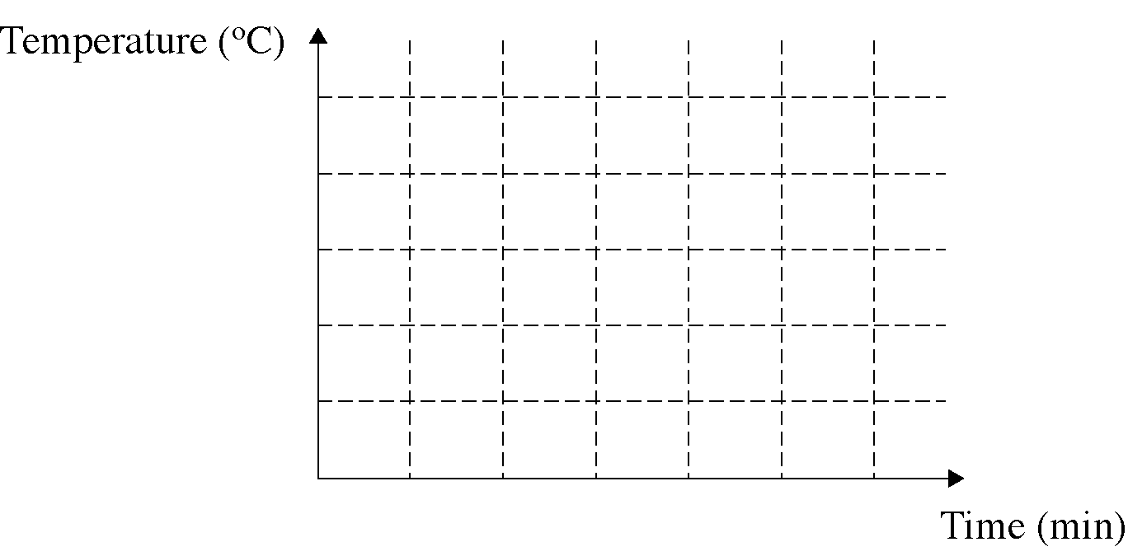

4EC018Q8
- What do the graphs show you?

4EC018Q9
- Imagine that the cups are left for a few hours. What do you think the final temperature
of the water in each cup will be?

4EC018Q10
- The three cups shown below are made from the same material. They have the same
amount of hot water in them. Which one do you think will cool the quickest? Explain.

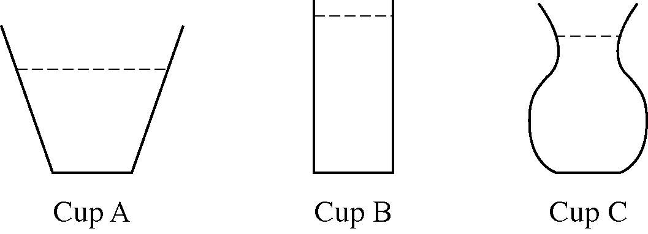

Marking guide
4EC018Q1
Q1 | Score 1 | [2B–Makes comparisons between events observed.]  Probably around 20⁰C, but answers could vary between 10⁰C and 30⁰C (average of three thermometer readings if they are different).
 | Score 0 | Other.
4EC018Q2
Q2 | Score 1 | [3B–Displays data as a table.]  Table fully completed.
 | Score 0 | Other.
4EC018Q3
Q3 | Score 1 | [3B–Identifies patterns in the scientific data.]  Black.
 | Score 0 | Other.
4EC018Q4
Q4 | Score 1 | [4C–Explains process reported in terms of an abstract science concept.]  Dark colours radiate heat quicker.
 | Score 0 | Other.
4EC018Q5
Q5 | Score 1 | [3C–Describes a cause and effect relationship.]  The initial water temperatures should be the same, but they could vary (cool down) during the time it takes to pour the water into each cup.
 | Score 0 | Other.
4EC018Q6
Q6 | Score 1 | [3A–Demonstrates awareness of the need for fair scientific testing.]  The same amount of water means it is a fair test.  Actual student responses:  - Because the more hot water there is the more heat will stay, thus meaning the experiment is unfair.  - Because we want to see how temperature changes through the appearance of cups, not through different volumes of water.
 | Score 0 | Other.
4EC018Q7
Q7 | Score 1 | [4B–Plots line graphs.]  Three lines on one graph with scale shown and correctly showing gradual decrease in temperature.
 | Score 0 | Other.
4EC018Q8
Q8 | Score 2 | [4B–Interprets data from line graph.]  All three curves have a similar shape, but they cool at slightly different rates. They all show gradually decreasing temperature with time. They all approach the same final temperature.
 | Score 1 | [3B–Identifies patterns in science data.]  All three curves have a similar shape and the temperatures are getting less.  Actual student response:  - The graphs show me the temperature dropped in each type of cup in every three minutes.
 | Score 0 | Other.
4EC018Q9
Q9 | Score 2 | [4B–Identifies patterns in science data.]  They will all be at room temperature.
 | Score 1 | [3B–Identifies patterns in science data.]  They will all be the same temperature.
 | Score 0 | Other.
4EC018Q10
Q10 | Score 1 | [3A–Identifies the variable to be changed.]  Cup A because it has the largest surface area exposed to the air.
 | Score 0 | Other.

